7.Design and Analysis of FIR Filters Using Parks–McClellan and Frequency-Sampling Techniques Using MATLAB
Objectives of this Experiment:
1. To design FIR filters using the Parks–McClellan equi-ripple method and frequency-sampling technique.
2. To obtain and analyze the FIR coefficients and desired frequency response for each method.
3. To determine passband/stopband ripple and transition characteristics from the simulated responses.
4. To compare the two FIR design methods using common frequency specifications.
PROGRAM:
clear; clc; close all;

Fs = 10000;
fp = 1500;
fs = 2000;
N = 40; % Filter order

% 1. Parks-McClellan (Equiripple) Design
f_bands = [0, fp, fs, Fs/2] / (Fs/2); % Normalized frequency band edges
a_bands = [1, 1, 0, 0]; % Desired amplitudes
b_pm = firpm(N, f_bands, a_bands);

% 2. Frequency-Sampling Design
b_fs = fir2(N, f_bands, a_bands);

% ==========================================
% DISPLAY NUMERICAL OUTPUTS IN COMMAND WINDOW
% ==========================================
fprintf('=== EXPERIMENT 7: PARKS-MCCLELLAN vs FREQUENCY SAMPLING ===\n\n');
fprintf('Filter Order (N): %d\n', N);
fprintf('Passband Edge: %d Hz, Stopband Edge: %d Hz\n\n', fp, fs);

fprintf('--- PARKS-MCCLELLAN COEFFICIENTS (b_pm, First 10) ---\n');
disp(b_pm(1:10));

fprintf('--- FREQUENCY-SAMPLING COEFFICIENTS (b_fs, First 10) ---\n');
disp(b_fs(1:10));

% Frequency Responses
[H_pm, f] = freqz(b_pm, 1, 1024, Fs);
[H_fs, ~] = freqz(b_fs, 1, 1024, Fs);

% Plotting
figure('Name', 'Parks-McClellan vs Frequency-Sampling');
subplot(2,1,1);
plot(f, 20*log10(abs(H_pm)), 'b', 'LineWidth', 1.5); hold on;
plot(f, 20*log10(abs(H_fs)), 'r--', 'LineWidth', 1.5); grid on;
legend('Parks-McClellan (Equiripple)', 'Frequency-Sampling');
title(['FIR Filter Magnitude Response Comparison (Order N = ', num2str(N), ')']);
xlabel('Frequency (Hz)'); ylabel('Magnitude (dB)'); ylim([-80 10]);

subplot(2,1,2);
plot(f, angle(H_pm)*180/pi, 'b', 'LineWidth', 1.5); hold on;
plot(f, angle(H_fs)*180/pi, 'r--', 'LineWidth', 1.5); grid on;
legend('Parks-McClellan', 'Frequency-Sampling');
title('Phase Response Comparison');
xlabel('Frequency (Hz)'); ylabel('Phase (degrees)');
OUTPUT:
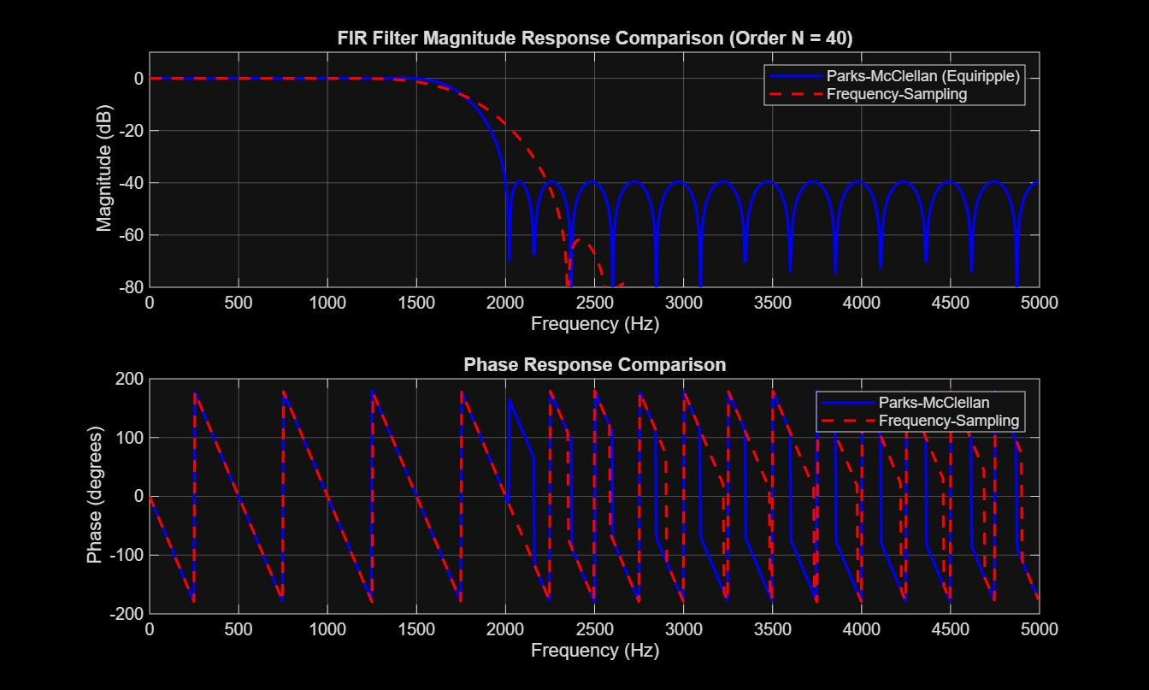
RESULT:
=== EXPERIMENT 7: PARKS-MCCLELLAN vs FREQUENCY SAMPLING ===

Filter Order (N): 40
Passband Edge: 1500 Hz, Stopband Edge: 2000 Hz

--- PARKS-MCCLELLAN COEFFICIENTS (b_pm, First 10) ---
-0.0015 0.0072 0.0053 -0.0010 -0.0081 -0.0072 0.0037 0.0142 0.0100 -0.0090

--- FREQUENCY-SAMPLING COEFFICIENTS (b_fs, First 10) ---
0.0000 0.0001 0.0002 -0.0001 -0.0008 -0.0009 0.0008 0.0035 0.0029 -0.0039

